Version 2.0

Task 0: Explain what you are doing/ going to accomplish

In this version I will create a “showcase” page for all of the dogs to show up on. This is where users will be able to browse the dog options to see who they would like to borrow for the day.

Task 1: Sketch interface design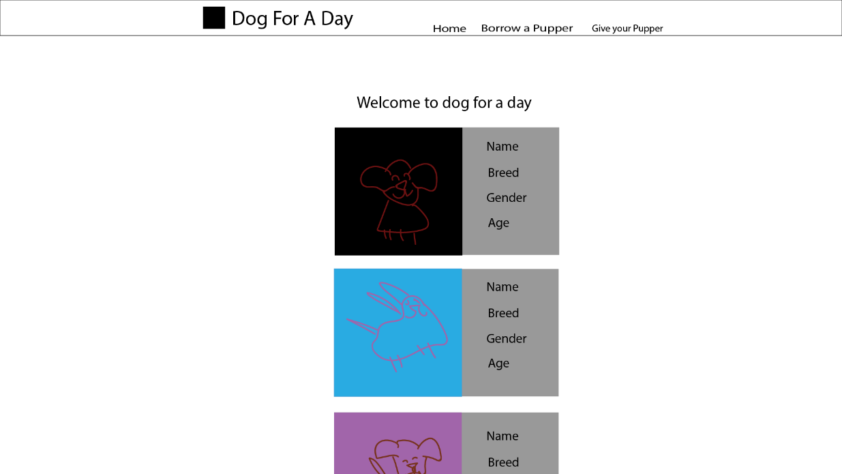

A middle column to showcase all of the dogs that are currently available

Task 2: Identify any classes required

Class Dog

Will need the variables, Name, Age, Description, Breed, Available, Gender

Task 3: Identify information to be displayed

This page will display the Dog class and all of its variables in the dog_list

Task 4: Identify user inputs

No user inputs for this version

Task 5: Identify any constants or existing data if required

No constants for this version

Task 6: Identify indexed data structures

Data dictionary called dog_list is used to get the dogs.

Task 7: Determine what calculations are necessary

No calculations needed in this version

Task 8: Develop a modular structure for your program

Set route to (‘showcase-page’)

Set view to (‘showcase’)

Set showcase function to:

Set var data to be dictionary of dog_list

Return data to page

Task 9: Define the functions identified

Showcase function – to send dog_list to the showcase page in the form of a dictionary

Task 10: Address any relevant implications such as usability, functionality, legal/ethical requirements.

It need to be functional, it should first fufill its purpose and secondly look aesthetically pleasing,

No copyrighted images. No illegal or explicit images etc.

I also in this case need to make sure that the images of dogs used are appropriate. They should be images that show the face of the dog in good detail so that the user can see what they are renting.

The purple buttons are used throughout the site to “teach” the user that purple colour is a button to carry on through the experience. I went through a few button designs.

First was purple with text. I liked the colour, however it was not “eye-catching enough”.

I tried changing the colour to orange, or a green colour, however I felt purple worked best. So I went onto emojipedia and found the eyes emoji, which is like saying to the user, I want to see this one. I thought the eyes emoji works perfectly for the application I am creating.

When deciding on the colours/design of the website I went through several similar sites to see what they use.

|  |  |  |
| --- | --- | --- |
| URL (As of 9/06/18) | Who? | Style |
| <https://www.sharemypet.co.nz/about-us/> | A share my pet website | White background, simple design, blue and purple accents. |
| <https://www.borrowmydoggy.com/> | Borrow my doggy, you can share your dog with others. Very similar to my website | White background, green and grey accents. |
| <https://walkeepaws.com/> | Walk a dog service, selling dog products | White background, blue and grey accent colour. Lots of pictures of dogs. |
| <http://www.lendapet.com.au/borrow> | You can rent you pet out to someone else. | Grey background, burgundy colour accent. White slides |

Due to the above sites all using a simple white background in the most part, I chose white my website as well. This is because it is clean and easy to read. Making my program more user friendly.

I chose purple accents for my site as it sets it apart from the other sites. With a grey accent to define borders/cards.

Using these colour systems consistently throughout the webpage should allow the user to have a consistent experience with the webpage. It also fulfils the aesthetic and minimalist design as it removes all of the unnecessary clutter within the pages that may distract the user.

Task 11: Document test cases for testing the program

Load, “localhost:8080/showcase-page”, and see if the page show up to how I imagined it within the interface design sketch.

Task 12: Refine the plan

None needed within this version

Task 13: Document testing

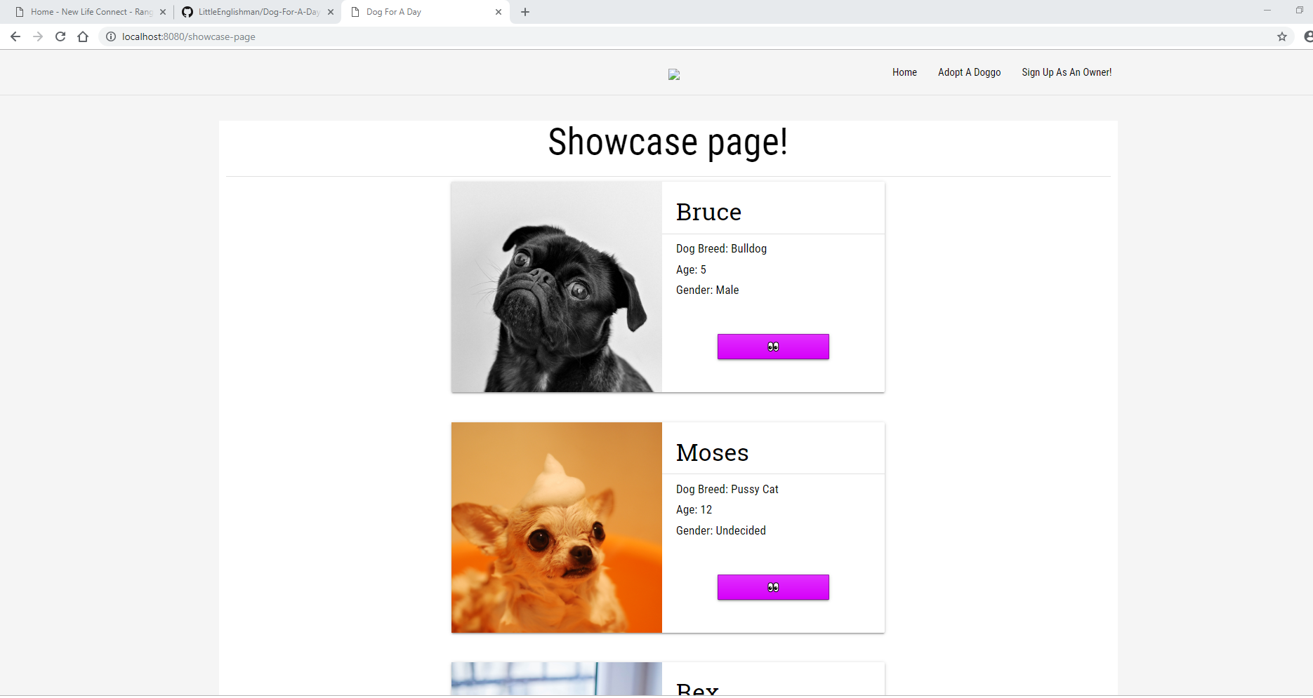

Here you can see the showcase-page working and showing up the list of dogs with information about each dog. As well as the buttons which show up in the correct purple colour.

Task 14: Evaluation

This version worked well, and I will eventually like to try get the dogs into two columns to use space on the website more efficiently, but for now I will focus on making it all work. I followed a basic and simple design which sticks with the theme of my overall webpage and this makes it a fluid experience.